Homework 1.

1. Create an RDF graph to describe yourself and 3 of your friends. State the relations between this group of people. Use FOAF vocabulary. For more information on FOAF, see <http://xmlns.com/foaf/spec/#sec-into> and <http://xmlns.com/foaf/spec/#sec-crossref> If you want to use a different vocabulary, please do so. You may also decide to use more than one vocabulary, but do not overly complicate your graph.

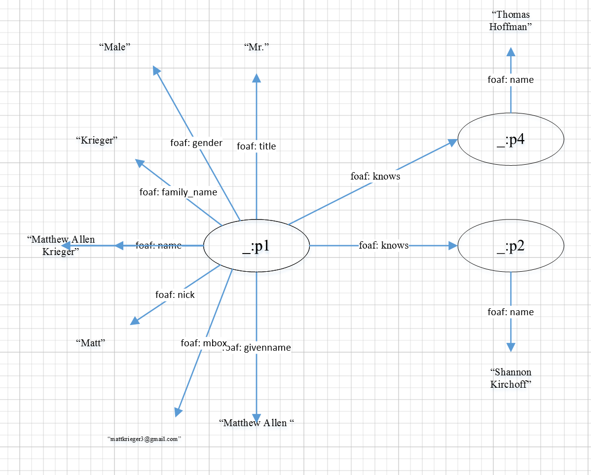

1. Serialize this RDF graph in Turtle to get .ttl file ready for further processing (to be used in the future).

@prefix rdfs: <http://www.w3.org/2000/01/rdf-schema#> .

@prefix admin: <http://webns.net/mvcb/> .

@prefix foaf: <http://xmlns.com/foaf/0.1/> .

@prefix rdf: <http://www.w3.org/1999/02/22-rdf-syntax-ns#> .

<> a foaf:PersonalProfileDocument ;

admin:errorReportsTo <mailto:leigh@ldodds.com> ;

admin:generatorAgent <http://www.ldodds.com/foaf/foaf-a-matic> ;

foaf:maker <#me> ;

foaf:primaryTopic <#me> .

<#me> a foaf:Person ;

foaf:family_name "Krieger" ;

foaf:givenname "Matthew" ;

foaf:homepage <https://github.com/mattkrieger3> ;

foaf:knows [ a foaf:Person ;

foaf:mbox_sha1sum "31cbd24449b490be8997f4a7110513f98bcac498" ;

foaf:name "Kimberly Snow "

] ;

foaf:knows [ a foaf:Person ;

foaf:mbox_sha1sum "8855c1b43c2f194d3468910d685ae0167b7b2604" ;

foaf:name "Shannon Kirchoff"

] ;

foaf:knows [ a foaf:Person ;

foaf:mbox_sha1sum "4852038eeaa0b04a43745ca10398382f5e06b137" ;

foaf:name "Thomas Hoffman"

] ;

foaf:mbox_sha1sum "5941a4e46ae418d310741cc93a969e8c2d3d9085" ;

foaf:name "Matthew Krieger" ;

foaf:title "Mr." ;

foaf:nick "Matt" ;

foaf:schoolHomepage <http://www.ccsu.edu/>;

foaf:phone <tel:8603316603> .

1. Select a small subgraph (for example, the portion about yourself) and represent it in RDF/XML format.

<rdf:RDF

xmlns:rdf="http://www.w3.org/1999/02/22-rdf-syntax-ns#"

xmlns:rdfs="http://www.w3.org/2000/01/rdf-schema#"

xmlns:foaf="http://xmlns.com/foaf/0.1/"

xmlns:admin="http://webns.net/mvcb/">

<foaf:Person rdf:ID="me">

<foaf:name>Matthew Krieger</foaf:name>

<foaf:title>Mr</foaf:title>

<foaf:givenname>Matthew</foaf:givenname>

<foaf:family_name>Krieger</foaf:family_name>

<foaf:nick>Matt</foaf:nick>

<foaf:phone rdf:resource="tel:8603316603"/>

<foaf:homepage rdf:resource="https://github.com/mattkrieger3"/>

<foaf:mbox_sha1sum>5941a4e46ae418d310741cc93a969e8c2d3d9085</foaf:mbox_sha1sum>

<foaf:phone rdf:resource="tel:8603316603"/>

<foaf:schoolHomepage rdf:resource="http://www.ccsu.edu/"/>

</rdf:RDF>

1. Go to <https://www.w3.org/RDF/Validator/> to validate your RDF file. To work with the validator, paste your RDF document intro the document window, and click “Parse RDF” button. Then, change the default choice in the dropdown list “Display Result Options” from “Triples only” to “Triples and Graph” to visualize the RDF graph and compare to your initial one.

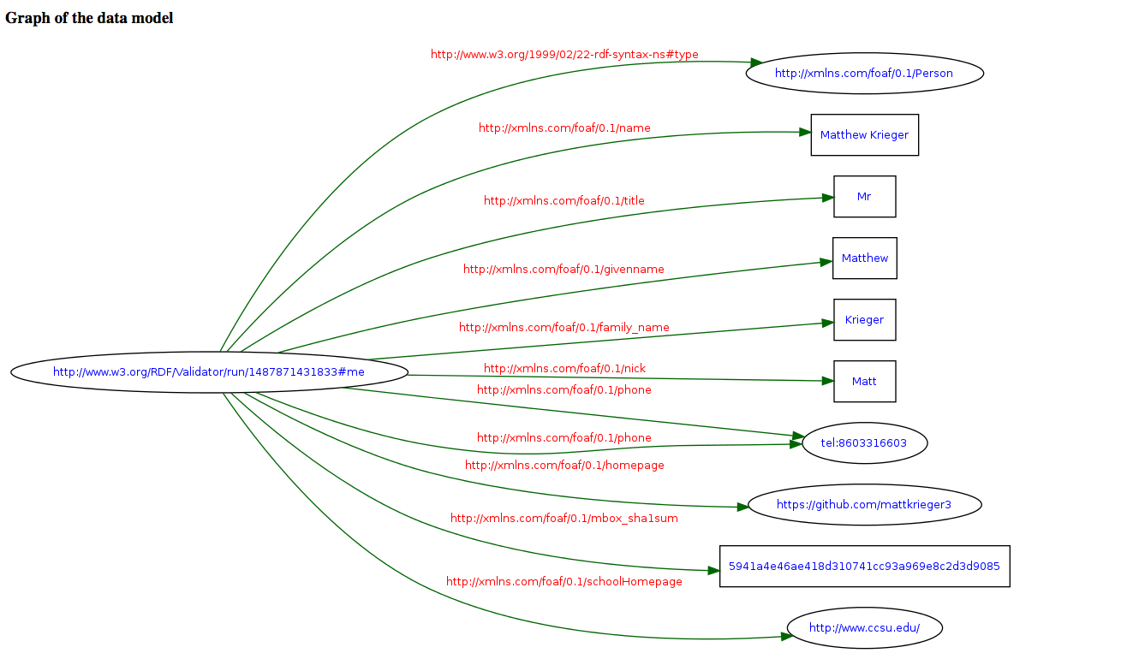

Show ALL the work following the outlined steps. Copy and paste windows and documents in Word and submit the .doc file for grading.